**Module 2 Activity 1: Basic Static Web Project Using Node.JS and EJS**

Naga Sumanth Vema

IFT 554: Middleware Programming & Database Security

Dinesh Sthapit

February 4th, 2024

**Module 2 Activity 1: Basic Static Web Project Using Node.JS and EJS**

Screenshot 1: Terminal window demonstrating the installation of EJS using the command

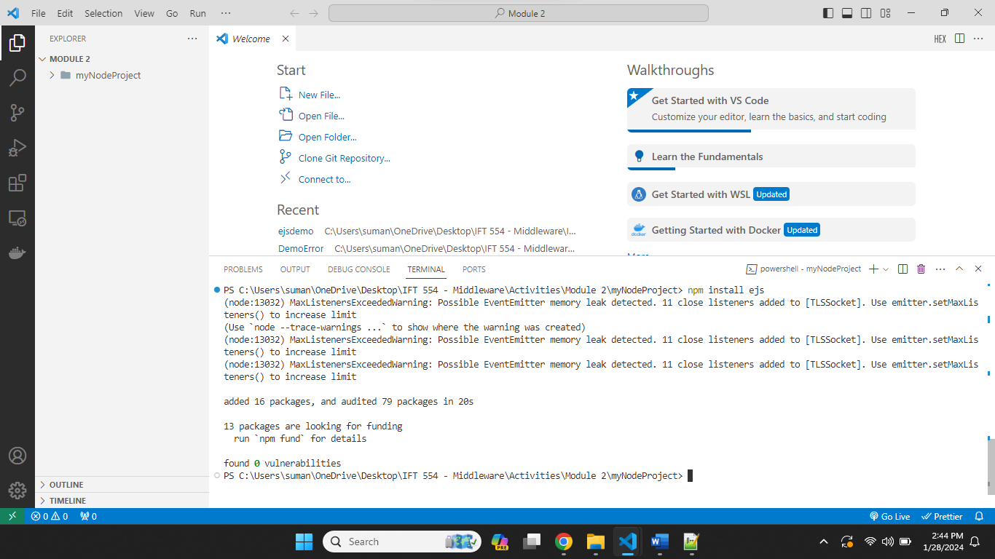

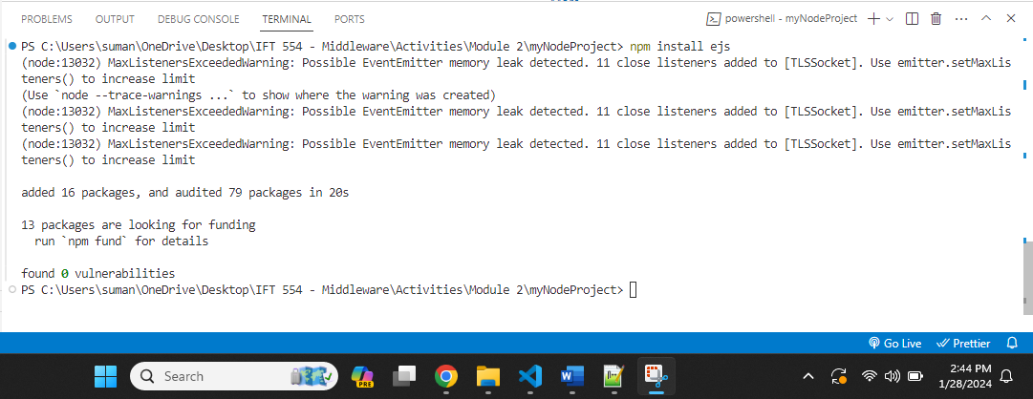

Screenshot 2: Visual Studio Code explorer displaying the creation of a new file named "app.js" within the project folder.

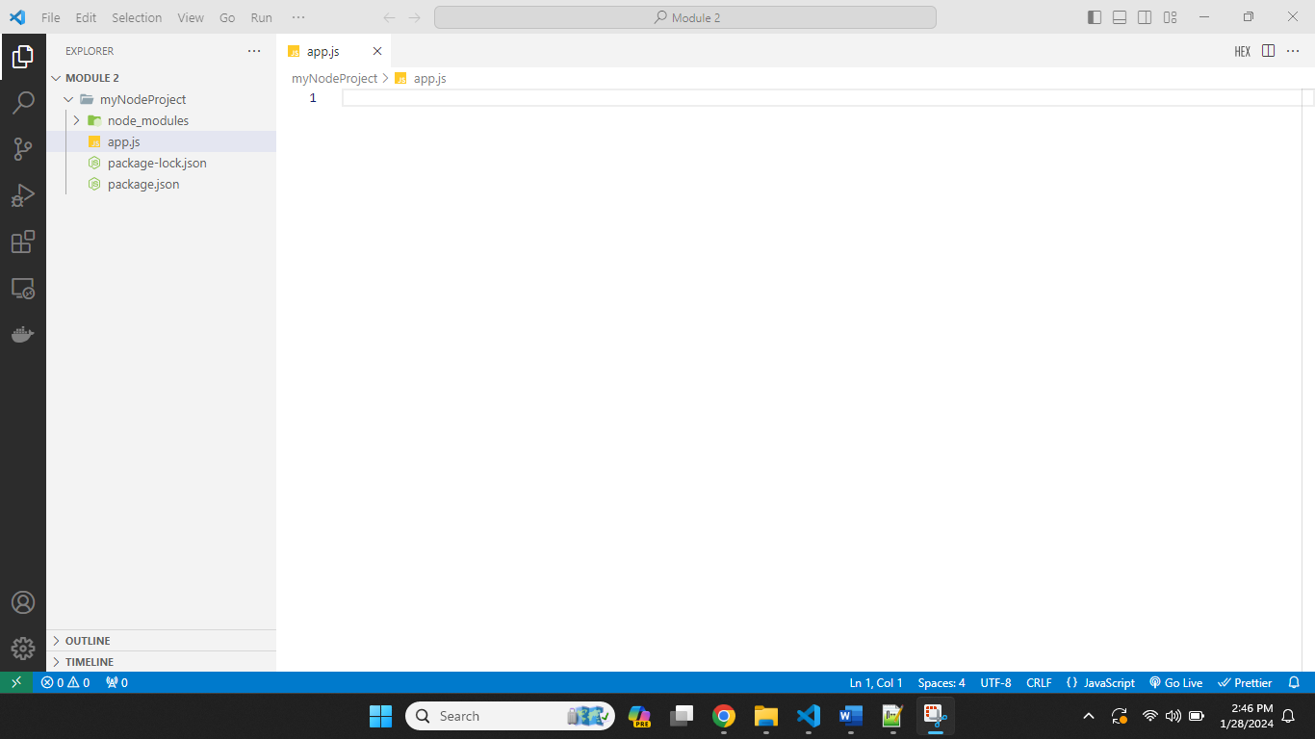

Screenshot 3: Editor view in Visual Studio Code showing the opened "app.js" file with code for setting up Express.js server and importing Express module.

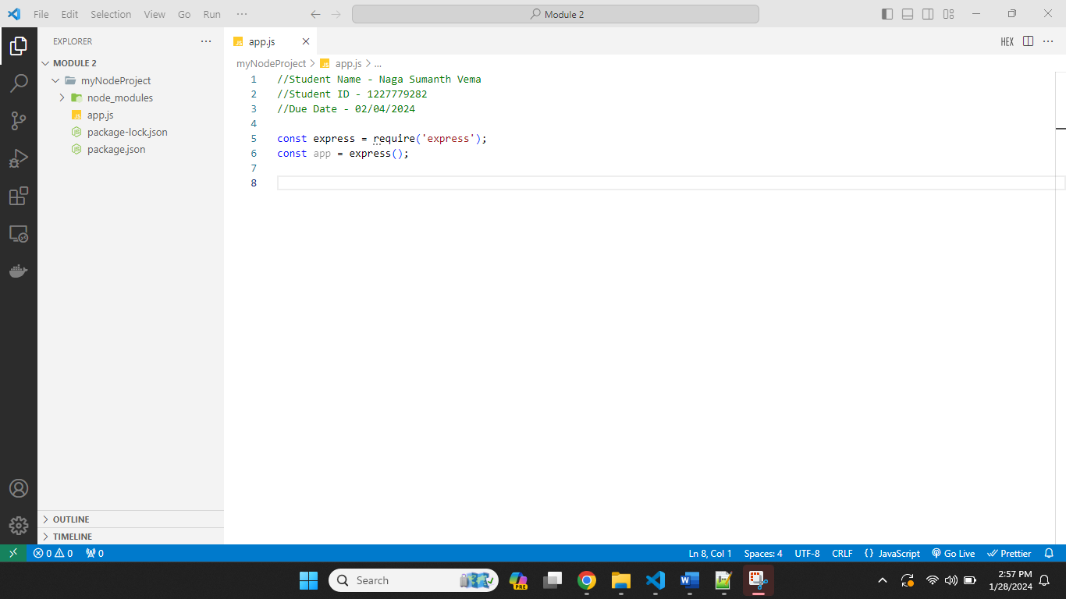

Screenshot 4: Visual Studio Code explorer displaying the creation of a new folder named "views" within the project folder.

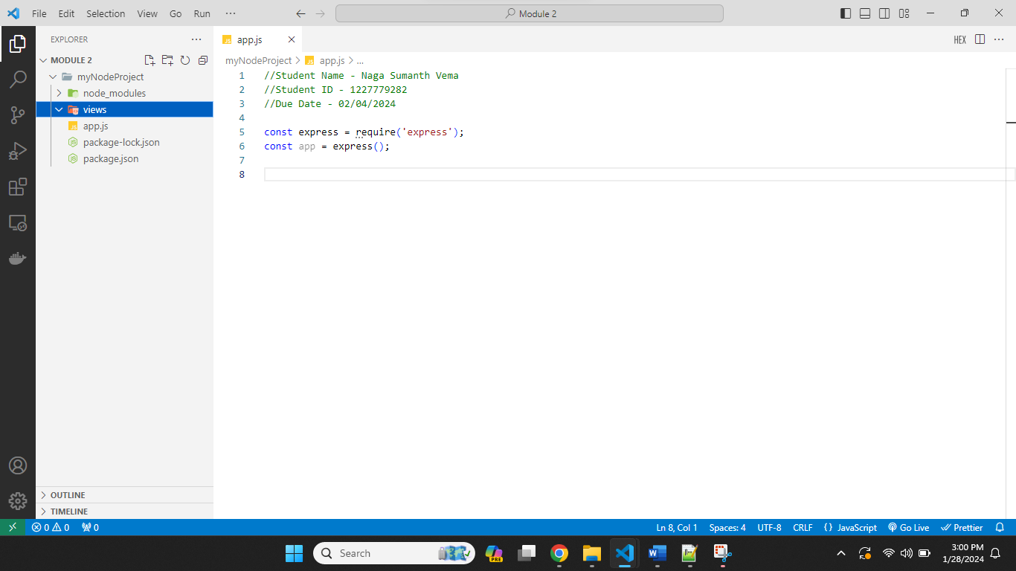

Screenshot 5: Visual Studio Code explorer displaying the creation of a new EJS file named "form.ejs" inside the "views" folder, showcasing HTML code for the form.

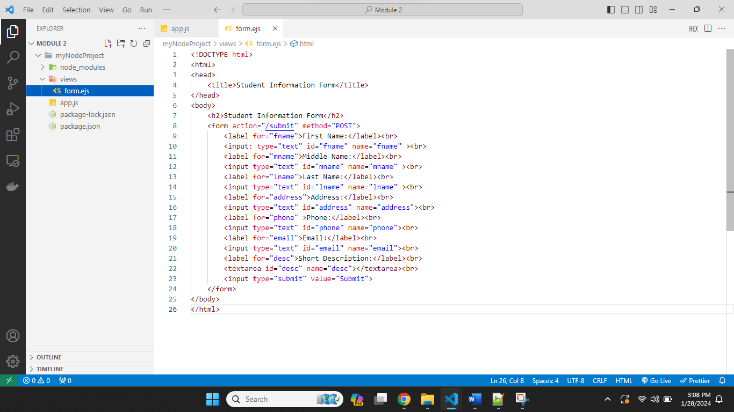

Screenshot 6: Visual Studio Code explorer or editor showcasing the added code in "app.js" to handle form submissions and parse incoming request bodies.

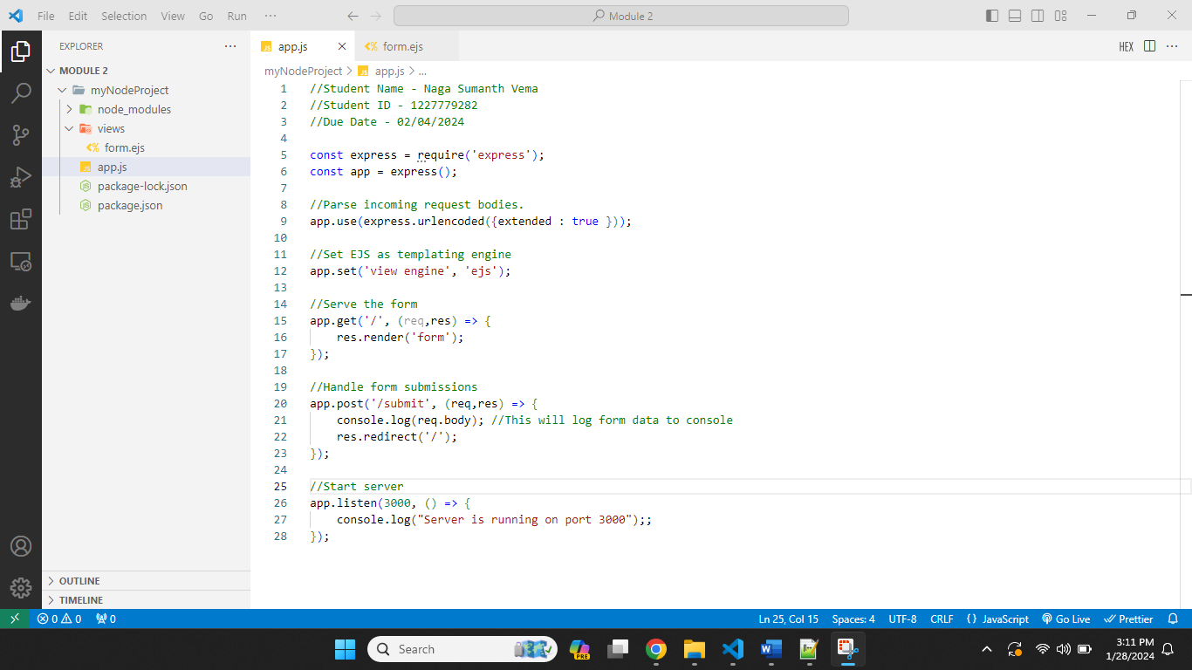

Screenshot 7: Terminal window executing the command node app.js to run the Node.js application and display the server running on <http://localhost:3000>

